# Project Name: Handling User Authentication.

## GitHub Link:

## <https://github.com/tamasjit/myjavaproject/tree/master/Phase%203/Phase-3_Practice_Project/q3_Authentication>

## Output:

### Landing Page:

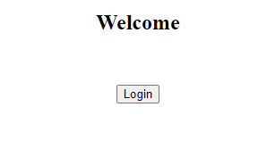

### Dashboard Page (Entering data for login):

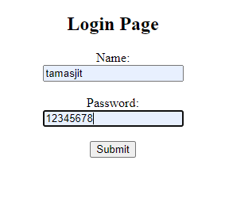

### For Wrong Login:

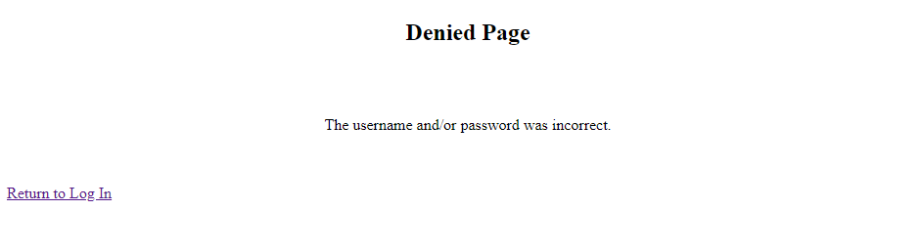

### For Successful Log in:

